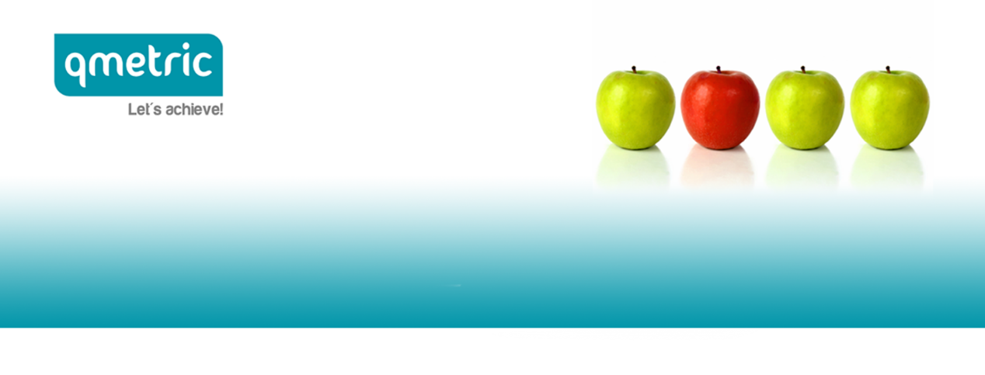

qmetric | HR Solutions is currently recruiting, on behalf of Welcome Pickups, the position of

RUBY ON RAILS ENGINEER
Our client

At Welcome we are redefining the way people travel by offering them the most personalized and complete experience. From the moment our customers step outside the airplane till they get back home, we provide them with the warmest, most informative and friendliest transfer from and to the airport, equip them with all the necessary products they will need during their trip, as well as stand by them for any information or product they need for the duration of their stay, through our mobile application.

Although we are just a 3-years old company, we have been named "Best New Solution in Travel for 2016", have welcomed more than 600,000 travelers across 28 destinations worldwide, gathered raving reviews for our level of service.

If you feel you are one of those stellar A-players who can join our mission to expand Welcome globally and create the perfect travel experience from start to finish, go ahead and apply for the position.

The position
The position will join an existing agile team of 3 Ruby engineers reporting directly to the Technical Product Management and work with the Operations and Customer Support teams to design and ship features that improve their performance.

What you'll do:
- Develop the next versions of our current APIs (quick documentation preview here) to support our mobile apps:
  - Driver Mobile App
  - Traveller Mobile App
  - Service Suppliers & Partners Mobile App
- Deepen the integration of Welcome with third parties. We already have a rather big set of integrations with APIs (Vero, Twilio, Firebase, Pushwoosh, Flightstats, Intercom, Zendesk and a series of Hotels reservation management systems. Part of your job will be to expand, update, monitor and maintain those integrations
- Engage in everyday challenges utilizing your skillset. Our product is highly used by people who depend on their everyday work (drivers, partners, operations) and our environment is scaling so quickly that you will face smaller or more challenging problems very frequently. We expect you to quickly engage and help other team members with your programming development skills.

Your profile
The ideal candidate needs to have extensive hands-on experience in Ruby and the Rails framework and ideally in designing, developing, testing and improving APIs for mobile apps.
More specifically we are looking for:
- 3+ years of proven work experience as a Ruby and/or Rails developer
- Demonstrable knowledge of front-end technologies such as JavaScript, HTML, CSS and JQuery. The team has dedicated Front-end & Mobile Apps developers
- Experience developing APIs for Mobile Applications
- A firm grasp of Ruby & Rails test frameworks (minitest / rspec)
- Good knowledge of relational databases (PostgreSQL)
- Familiarity with NoSQL databases / stores & ElasticSearch
- Ability to coordinate with remote team members
- BSc/MSc degree in Computer Science, Engineering or in related field
- Passion to work in an ever-changing environment and in a company that grows 4x every year.

Our client offers
- Salary based on your experience
- A great working environment, full of drive and energy
- The tools you need to perform your daily tasks, including a computer workstation of your choice.

Are you interested? If so, click here to submit your application!

Our company treats each application with strict confidence.

